**LIBERTON KIRK NEWS EXTRA**



**25th March 2020**

Dear Friends,

Hi everyone we are hoping to send you the news extra more regularly over the next few weeks. Due to the restrictions on our movements you will receive this by post as long as the postal service is functioning.

You will all be aware of the changing times we are currently living in. A time of uncertainty and frequent changes. The one thing that remains without change or uncertainty is our God. Our faith may waver as we listen to the news but I hope we can encourage each other that God is with us and does care about what is happening around us.

The pasoral team are trying to keep in touch with you all by phone as we cannot visit at the moment. So hopefully you will have heard from one of us by now or will receive a phone call soon.

There are so many good things happening. People setting up groups to keep in touch with their neighbours. Our own café manager set up a whats app group for café volunteers and they keep in touch share news, funny stories and serious things that we can all be praying for. There are many examples of people shopping for others, volunteering to help the health service and many more. We would love to hear from you with your stories and we can include them in our weekly bulletins. I will put my phone number at the end of this news extra.

You can also use this number if you need some support at this time.

With much love

Linda (Phone Number 07850411596)

Jacqui (secretary’s) grandchildren in lockdown

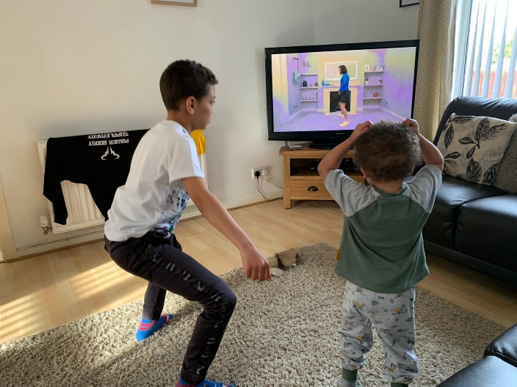 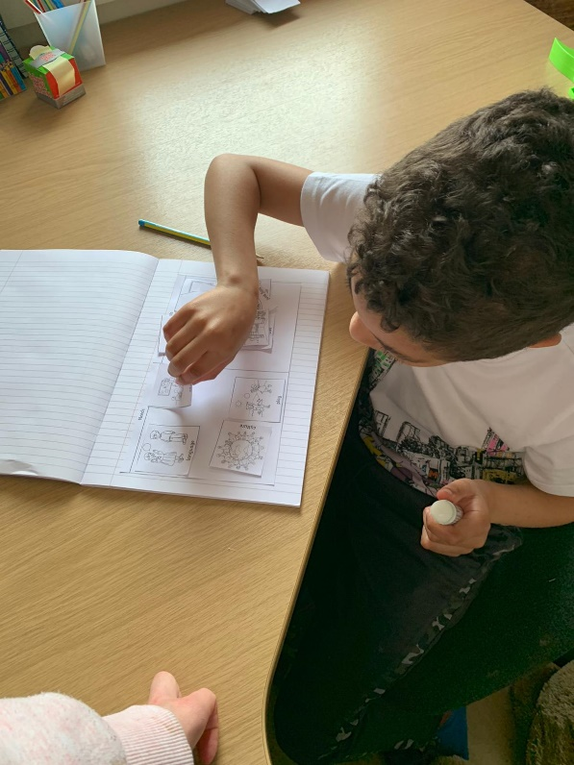

Joseph being home schooled

Joseph and Robbie doing their daily workout

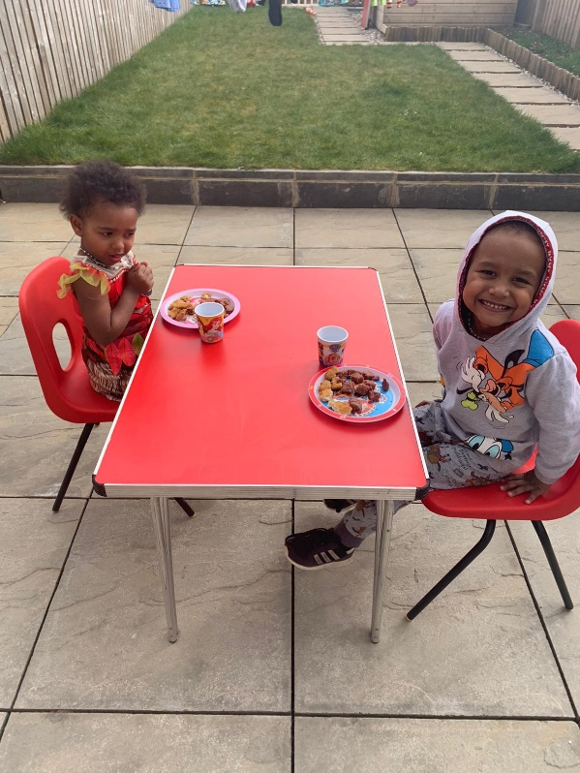 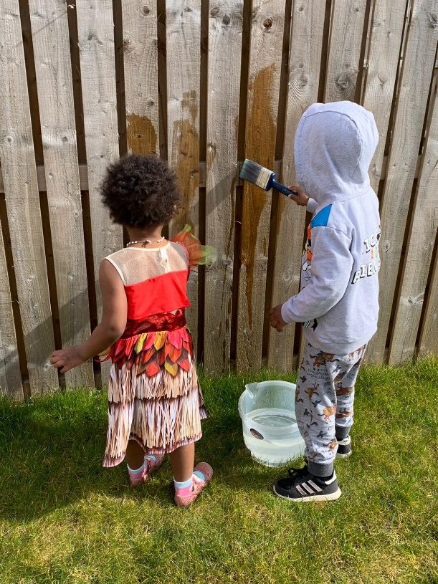

Painting the fence with water

Modou and Nancy enjoying lunch in their new garden