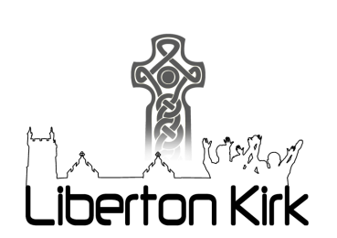

Liberton Kirk Sunday Notices – 16 August 2020

- The Sunday morning service at 10.30am is relayed on Zoom. All those with internet access should contact Gary Ross (rollkeeper@libertonkirk.net) for details. For those with no internet access it is possible to follow this service in the Kirk, but because of the restriction in numbers you must contact John Young on 664 3067 first. If you are in the Kirk, please observe the guidelines noted on page 2.

- Peace Pathway – open in the kirkyard throughout July and August from 8am to 8pm as an opportunity for meditation and prayer.

- Kirkgate Café – Now open from 9am to 2pm on Mondays to Thursdays, within restrictions and guidelines. Outdoor seating area available. Contactless card payments possible.

- BYOC (Bring Your Own Cuppa) – Wednesday 19 August, 10.30am-12noon – zoom gathering for a chat and coffee – login details available from Gary Ross, further details from Alastair Cameron.

- The August edition of Crosstalk, the quarterly newsletter of SEECAT (South East Edinburgh Churches Acting Together), is now available on the SEECAT website www.seecat.org There are also some printed copies available in the Kirk Centre entrance.

- The September magazine is the issue which is distributed to all households in the parish. If you would be able to help with bundling on Friday 21st August from 10am please contact Mary Davidson on 664 6789. Thereafter, bundles will be available in the Kirk Centre to pick up and deliver before the end of August – we suggest you wear gloves for this job. Please help if you can. Bundles will also be available for the usual magazine distributors with districts outside the parish.

- The Moderator is calling the whole of the Church of Scotland to a Week of Prayer from 17th to 22nd August, to come together to hear what the Spirit might be saying to us in these days. There will be a daily reflection on the Church of Scotland website or Facebook page (from 8am) and in the evening at 8.30pm a Zoom gathering where participation will be possible for a time in breakout rooms. If you would like the Zoom joining information contact John Young on 664 3067.

- Liberton Kirk now has a YouTube Channel, which will have recordings of Zoom Service readings and talks during lockdown. Please sign up to this. We plan to use it for reflections and live streaming in the future - https://www.youtube.com/channel/UC1xk4wcs5vEPozVE3-LFjJA/featured

- Safe Families – Online training for those interested in volunteering with Safe Families has been organised for Tuesday 25 August from 7 to 9pm. Sign up at https://Safe Families.uk/volunteer. Further information available from Eleanor Grieve or at scotland@safefamilies.uk.

