Liberton Kirk Guild: #wearebusy!

At the beginning of September over two evenings, Helen Campbell and Ann Weir hosted “Cook’n’Chat”. In a relaxed informal setting, in the Kirkgate Cafe the evenings started with mocktails and canopies. This was followed by demonstrations in the kitchen of various savoury and sweet dishes with the opportunity to make some of the dishes. The evenings finished as everyone sat down to eat the food that was cooked while chatting and sharing cooking tips as well as catching up with other news. Of course, no event is complete without a goody bag. This event was a great success thanks to Helen and Ann. We have the promise of another evening when everyone will come together and share their own favourite dish.

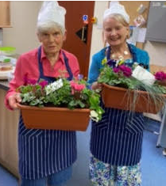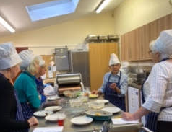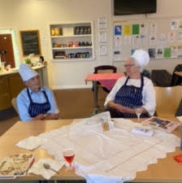

On Saturday 10th and 25th September the Liberton Kirk Guild invited people of all ages to join them on two short historical walks around our local area. These walks were led by Ruth Davies who has considerable knowledge of our neighbourhood. As well as learning about our local history it was also a great time to meet new people and catch up with old friends. Each walk rendezvoused in our Cafe with refreshments. We knew it was a success as nobody wanted to go home!

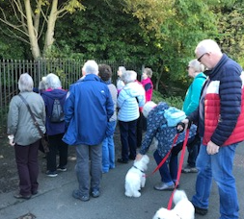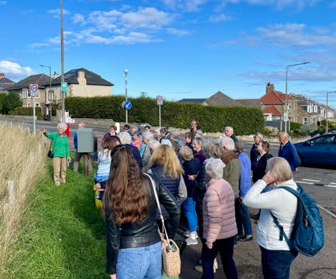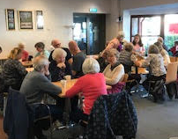

Our new session began on Monday 3rd October when we held our Dedication Service in the Kirk led by John Young our minister. During the service Ann Weir who has recently celebrated her 90th birthday, received a Long Service Award. Ann’s Granny and Mother were members of Liberton Kirk Guild and as a little girl Ann would sometimes go to the Guild meetings. This was a well-deserved certificate.

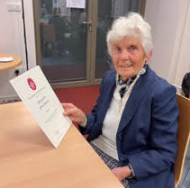

GM

October 2022

