THE GUILD
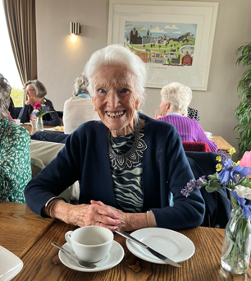
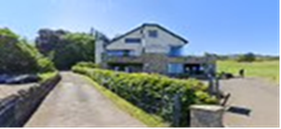
On Thursday 4 May we enjoyed an Afternoon Tea together at Swanston Brasserie. A lovely way to finish a very busy Guild Session, relaxing and having time to chat together. We also celebrated Jessie Burns 97th birthday!
